Career Development
Workbook

Contents

About this workbook 3
Taking the next step 4
Career paths 6
Barriers 8
What panels look for 10
Your support network 12
Key stakeholders 14
CV and applications 16
Interviews 18
Career planning 24
Next steps 35
Additional notes 39

About this workbook
This workbook has been developed to give you the space to help think about what is next and how you will get there. It is a collection of exercises designed to generate some thoughts and help keep you accountable to the steps you need to take to further your career to the next step; whether that be an Executive Director role, or another leadership role.
It is not a tool that will give you all of the answers, or that will assess what you should do but should be used as a way to reflect on what you have heard during our workshop.

Taking the next step

Why do I want to be a director?

What do I want my next role to look like?

Write a detailed description below of what you would like your next role to be. This could include job title, responsibilities, nature of the organisation and its challenges. Also describe the culture and values you would like it to have and how this would be demonstrated by the CEO and the board. What would success look like in this role?

What is my longer-term goal?
Describe what this role will lead onto. This does not have to be defined by a specific role but could be focused around the impact you would like to be making, the scale this is on, the people you will be working with. What does this look like? What would success look like?

Key factors
List below, in order of importance, the ten most important factors for you in finding your next role. This could be salary, location, culture, values etc.
1.
2.
3.
4.
5.
6.
7.
8.
9.
10.

Career paths
Career paths have changed over recent years, and this is now also starting to become evident within the NHS. Career options and executive roles may potentially be different to what we have seen in the past. We therefore need to adapt how we plan and structure our careers.
Previously, career success was defined by upwards linear progression. Now, as the healthcare system evolves and changes, career moves can occur in a variety of directions.
Often career moves may present themselves based on opportunities or unplanned events, known as “Happenstance Theory” . In order to ensure you are in a position to make the most of these “unplanned events”, the following questions will be helpful to answer.
- Recently - how have unplanned events influenced your career?

- How did you enable each event to influence you?

- How do you feel about unplanned events in your future?

- How is your curiosity excited? How could you explore the career implications of your curiosity?

- What is one chance event that you wish would happen to you? How can you act now to increase the likelihood of that desirable event?

- Not all chance events are positive. How have you tended to react to negative chance events? If you’ve tended to react with discouragement and inaction, how could you instead react by feeling challenged to exert even greater effort?

1 Happenstance theory
1Mitchell, K.E., Levin, A.S., & Krumboltz, J.D. (1999). “Planned happenstance: Constructing unexpected career opportunities.” Journal of Counseling & Development, 77, pp. 115-124.

Barriers
Being able to predict any potential barriers to your progression and how you will overcome them will give you the best possible chance of success in progressing to a board role within the NHS.
These barriers may be either internal or external. Internal barriers are mainly psychological and they can be powerful enough to scupper even the best laid career plans. Common blocks can include a lack of confidence, lack of focus, fear of failure etc.
Internal barriers
Barrier | Action I will take to overcome

External barriers
Barrier | Action I will take to overcome

What panels look for
Fill out the sections below with examples of your experience that evidence the following criteria.

Technical

Are you ready to operate at board level?

Leadership and self awareness

Understanding of the National Agenda

Your support network
Who is in your support network, how can they help you (think both inside and outside of your career and organisation)?
Have you spoken to family and friends about your next step? Can they offer you support?
Fill out the table below with your support network and the role each will play. How will you work with each individual to ensure you have the right support?
Coach
Helps you overcome specific performance challenges and improve your contribution
Mentor
Provides long-term support, guidance and wisdom
Collaborator
Person in a similar situation to yours with similar interests and goals
Connector
Bridge-builder who helps connect you with others
Encourager
Provides motivation and recognition for your achievements
Counsellor
Provides emotional support and encouragement

Additional people who can provide support

Key stakeholders
This exercise is to help you consider who the key stakeholders are that can help with your search for a new role. These may be people who can open doors for you, they may be others who can provide feedback on your strengths and development needs or it may just be simply helpful if they are aware of your search. This could also include Executive Search firms, NHS Improvement or NHS England.
You could either draw a mind map below, or write a list. You need to consider who they are, why they may be helpful and your plan for making contact or engaging them in your search. Even if you are not proactively looking for a role now these are people that you should be starting to make contact with in order to build your profile.

2 A mindmap is an easy way to brainstorm thoughts visually without having to worry about order and structure. It is usually organised with the key theme at the centre using a non-linear graphical layout.

CV and applications
The majority of board roles you apply for will be with a CV and supporting statement, particularly if there is an Executive Search firm involved. Creating a strong CV is part science, part art. You will often receive different opinions on what a good CV should look like and trends for CVs will change over time. Below is a checklist which can help assess if your CV is ready for applying for a board level role.
Note: Whilst you will have a static CV document, it will ALWAYS need to be tailored to the opportunity you are applying for.

Basics | Have you updated your CV in the last three months?
 | Is your CV easy to read, with simple clear layout and efficient use of white space?
 | Are your aspirations clear from your CV?
Content | Does your CV focus on achievements and how you have impacted others including your organisation?
 | Are these achievements quantifiable?
 | Is it clear the impact that you made in each achievement?
 | How clear is the scale that you have worked at?
 | Is your CV selling you as a Director?
Selection of Examples | Leading not just supporting
 | Strategic examples not just operational/tactical
 | Collaborative not siloed
 | Internal and external
 | Organisational wide
 | Exposure to board and directors

Ask someone you trust to review your CV.

Interviews
There is a lot that you can do for interview preparation before you even start applying for opportunities, allowing for your due diligence and tailoring of examples to be the focus when you have a specific opportunity arise.
Interview preparation
As part of any interview preparation you should ensure you can provide evidence and examples to bring your experience to life. There are two ways you can prepare this evidence.
Identify the eight most important criteria for the CEO in appointing this role (eg. system leadership, exposure to board, assurance, leadership). Develop two or three examples for each of these criteria based around the STAR technique, using either an intermediate or advanced level answer.
The eight key areas a panel would test when interviewing me for my first director role would be:
1.

2.

3.

4.

5.

6.

7.

8.

3 STAR Technique: Structure to be used to detail examples or stories told at interview – Situation, Task, Action and Result.

Interviews
Use the clock below to identify a range of 12 stories. In order to develop these stories, ask yourself the following questions and write a few key words related to each story in each segment.

- What is something I have achieved that I am most proud of?
- What are the quantifiable numbers associated with this example?
- What did I actually do to make this happen?
- What did I learn from this?
- What was the financial impact?
- What was the impact on patient care or staff?
Interview questions and answers
From the workshop use the space below to focus on interview questions you may find challenging and what panels may be looking for in your answers.

Career planning
What do I currently bring to the role?
Reflecting on what you have heard over the workshop, answer the questions below about your skills, knowledge, experience and behaviours. It can help to talk to as many people as possible to build up an accurate picture of these skills and how you are perceived by others.
This will help you to assess your readiness for an executive director role and how well you match to individual opportunities. It will also help in your preparation for applications and interviews in the future. The more detail you can give here the more it will help when you apply for roles.
What skills do I currently have?

Skill | Example

What knowledge do I currently have?

Knowledge | Example

What experience do I currently have?

Experience | Example

What behaviours do I currently utilise?

Behaviours | Example (what behaviours will help me as a director?)

What leadership styles do I adopt?

Leadership style | Example of where I have used this style with positive effect

What gaps do I have?
Now consider your gaps or areas for development. Compare your skills, experience and knowledge with the role remit and what you have heard during the programme. Assess where you may need to do further work. Talk to your manager, peers and subordinates to gain feedback.

You will not address all of your gaps before you apply for roles. No one will expect you to be the finished article but you will be expected to know where you might need further development. Consider the gaps that you currently have, whether you can address them and if so, how? If there are gaps that you are unable to address before applying, consider how you would address this in an interview situation and what development you would need in role if you are appointed.

What skill gaps do I currently have?

Skill | Example (how can I fill this gap or how I would address in an interview situation)

What knowledge do I need to gain?
Knowledge | Example

What further experience can I gain either before or after I am appointed?
Experience | Example

What behaviours might I need to change?
Behaviours | Example

What styles do I need to develop or use the least? Do I overuse a particular style? Do I know how to get the best out of people? How can I develop my leadership style?
Leadership style | Example

Next steps
Actions
You should now develop an action plan with timeframes. For each action consider who you will need support from and what challenges you might need to overcome. How will you know when you have achieved the below actions? What will good look like? How will you be accountable for delivering the below actions?

Timeline | Action(s)
Immediate – what am I going to do now?
Within the next three months
Within the next six months
Within the next year

Skills wheel
The tool below can be useful to help you identify your areas for development or the areas you feel less confident in pursuit of a board level role.
Around the outside of the wheel write the eight main areas that the appointing panel will be looking for in your application for a board level role eg. exposure to board, strategy, system leadership etc.
On each spoke there is a scale of 1-10. Plot on each spoke/line how confident you feel in that area.
Join the marks on each spoke, and this will then allow you to see clearly where your focus on development should be.
Answer the questions on the following page.

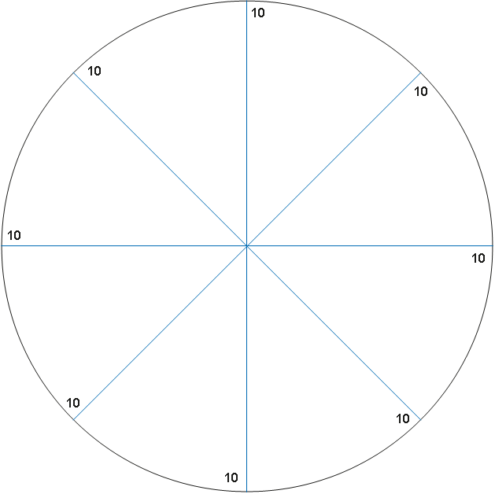

Skills Wheel
What are the two areas that you feel the least confident in?

1. | 2.
What would help you move from X to Y? | What would help you move from X to Y?
What can you do to develop this skill/area? | What can you do to develop this skill/area?
Who can support you? | Who can support you?

Additional notes

