Primary Care Leadership Collaboratives
Application Form

Be part of this exciting development opportunity, enabling people from across different professions within Primary Care in the East of England to enhance their leadership and improvement skills.
Are you passionate about improving the quality of care, service transformation and innovation across the wider system?
Are you already working and leading collaboratively across professions, organisations or networks to ensure better outcomes for patients?

eoe@leadershipacademy.nhs.uk

Great health care needs great leaders and leadership from across the system. The Long Term Plan (2019) and The NHS Five Year Forward View (2014) set out this vision of breaking down organisational and professional barriers to ensure people receive seamless care. In aspiration and in design, the Primary Care Leadership Collaboratives (PCLC) reflects and capitalises on the opportunities presented to the system by the vision articulated in the Long Term Plan, in particular around integrated care and other new models of service delivery aligned to the development of Primary Care Networks.

Section 1: Introduction
Applicants for the PCLC will already have some leadership experience commensurate with their role. By leadership we don’t necessarily mean formal team leadership, rather leading in the context of the shared initiative.

What are Primary Care Leadership Collaboratives?

The Primary Care Leadership Collaboratives are designed to support local teams in developing leadership capabilities in each of the east of England Integrated Care Systems and Sustainability and Transformation Partnerships (STPs)
We are seeking up to eighteen collaboratives in total, likely to be a Practice Manager, Practice Nurse and GP/GDP but potentially including other senior colleagues in practices, primary care networks and other local organisations. Individual practices or PCNs can form their own collaborative to attend and could use the programme to develop a quality improvement initiative within their Practice/PCN. Alternatively a group of PCN’s may wish to form a collaborative. We anticipate each collaborative will already be working together to improve health and health outcomes for their population and communities. Our goal is to enable improvement, integration and innovation across ICS/STPs through the collaboratives, sharing a common purpose and vision of primary care and future outcomes for communities.
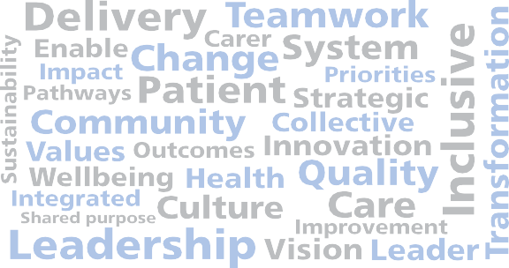

Cost

Please note that each place represents an investment of £1,000.

This programme requires full attendance over a series of impact days and should be fully supported by your line manager as part of your PDP. Inability to attend all days will have an impact on both personal development and programme delivery

Application Form

Only one application form is necessary per collaborative so in the first instance the collaborative should nominate a lead representative for administrative purposes.

Each collaborative will usually have 3 members but
could have up to 5.

The lead representative has the responsibility to ensure the application form is filled out on behalf of others in the collaborative.

It is also advisable that you contact your Primary Care Team representative to discuss suitability of your collaborative and its shared initiative.

Please submit the completed application form on behalf of you and the collaborative electronically by 10.00am on Monday 6th January 2020 and send to : eoe@leadershipacademy.nhs.uk

If you need any specific support in completing the application form by the deadline please let us know by contacting us at: eoe@leadershipacademy.nhs.uk

N.B. Before completing the application please check that you and the collaborative can be available for all 3 dates in Section 3.

Successful collaboratives will be notified
by 5pm on Monday 17th January 2020.

Section 1: Personal details

Which Sustainable Transformation Partnership (STP) /Integrated Care System (ICS) is your collaborative working within?
Suffolk and North East Essex ICS/STP
Norfolk and Waveney STP
Bedford, Luton and Milton Keynes ICS/STP
Mid and South Essex STP
Hertfordshire and West Essex STP
Cambridgeshire and Peterborough STP

Collaborative member (lead participant of the collaborative)
Name
Role
Organisation name
Email address and phone number

Collaborative member
Name
Role
Organisation name
Email address and phone number

Collaborative member
Name
Role
Organisation name
Email address and phone number

Impact day dates: Wednesday 12th February 2020, Wednesday 15th April 2020, Wednesday 20th May 2020.
We confirm that we have organisational agreement to attend all impact days.

Health Education England and the East of England Leadership Academy are committed to improving health and health outcomes for communities. The opportunity presented to the system by the vision set out in the Long- Term Plan and the NHS Five Year Forward View relies on working together across primary care and professions. Each applicant on PCLC will be supported individually and collectively to ensure that the collaboratives’ shared initiative and purpose is enabled and developed to achieve its potential to improve health and health outcomes for the local population and communities.
About the collaboratives initiative of improving health and health outcomes for communities

Please tell us what priorities the initiative supports delivery of (these may be specific to your STP):

The collaboratives’ initiative supports delivery of the following:

In this section we ask you to provide further information about the work you are currently working on and why you are all applying to take part in PCLC.

Section 2: Supporting evidence
Please give full and specific answers which demonstrate how participation in PCLC will benefit you, the collaborative, your organisation and Primary Care Network, as well as the community.

Please complete the following questions in the boxes provided.
1. Please describe:
a) The nature of the joint work you are undertaking together
b) Your roles within that joint work

2. Please outline what the collaborative will bring to PCLC in terms of skills, knowledge and behaviours. Please provide the collective view.

3. What does your collaborative hope to gain from the PCLC:
- As individuals within the collaborative for the benefit of patients
- For the local Primary Care Network and system
In this section please be as specific as possible about learning objectives, what successful delivery will look like and any other benefits there will be personally, for the collaborative and for the organisation(s) that you work in as well as the local system.

4. If you achieve your goals, what tangible outcomes will be evident?
- For the organisation you represent?
- For the local network and system?

Section 3: Primary Care Leadership Collaboratives dates

You will need to ensure that you and the collaborative are free for all of the dates.
Impact Days dates
Feedback from previous collaboratives

“Starting this programme is a huge positive. People need different skills than in the past, and it is difficult to find people to take leadership. Hands on help is essential”.
One example – a collaborative leading a group of 19 practices to provide more effective signposting for patients at the same time as streamlining access to appointments – shows that seemingly small measures, if well planned and implemented, can free up GP time and secure approval from patient representative groups. Many participants found that the programme increased their confidence enabling them to pursue improvements, as well as equipping them with knowledge about leadership styles and improving their communication, negotiating and influencing skills.

Wednesday 12th February 2020

Wednesday 15th April 2020

Wednesday 20th May 2020

Venue for all Impact Days: Holiday Inn, Impington, Cambridge

To provide the optimum shared learning and
networking opportunities this programme will be held in a location which is centrally based.

In addition to the dates outlined above, applicants will also be expected to engage with local activities and networks to support their personal development, as well as delivery of the initiative across the region.

This can include accessing coaching and/or mentoring and completing the Healthcare Leadership Model 360 in addition to involvement with local networks of support, including your sponsor and line manager. It may also include self-directed learning, for example accessing online materials or attending other local master classes and events. You will also be applying the learning from the PCLC by testing out improvement tools and techniques in the workplace and bringing your experiences and reflections back to share with fellow participants.

In order to get the most from PCLC, we would expect each member of the collaborative to spend around 8 hours a month on additional development activities, such as networking, coaching and self-directed learning.

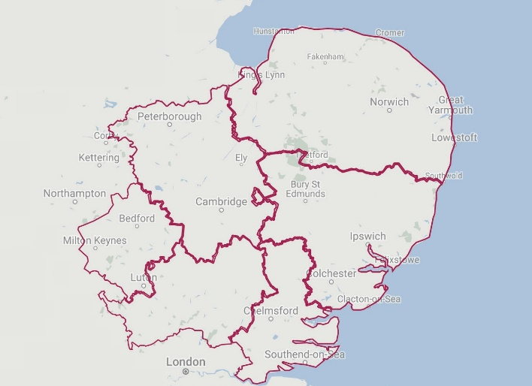
1
6
2
5
3
4

Key:
1: Norfolk and Waveney STP
2: Suffolk and North East Essex STP 3: Mid and South Essex STP
4: Hertfordshire and West Essex STP
5: Milton Keynes, Bedford and Luton STP 6: Cambridgeshire and Peterborough STP

